CARLTON PUBLIC SCHOOL

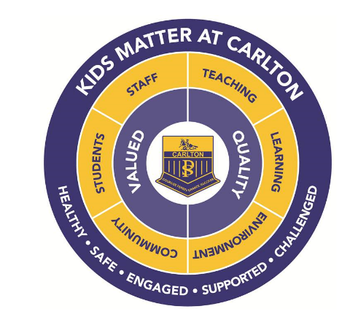

A - Z
Parent Information
Book

2019

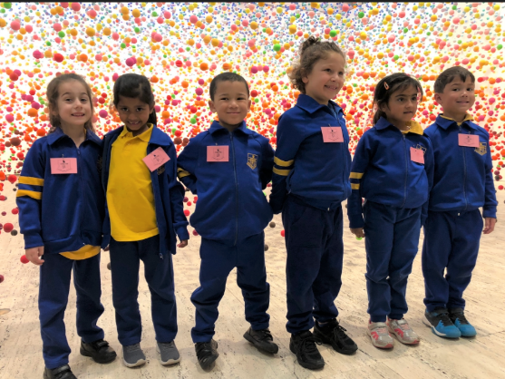
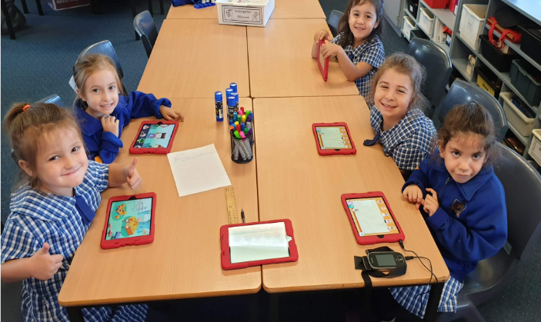

Carlton Public School
60 Cameron Street Bexley NSW 2207
T 9587 3717
E carlton-p.school@det.nsw.edu.au
W www.carlton-p.schools.nsw.edu.au

A-Z Index
Topic | Page | Topic | Page | Topic | Page
Aboriginal education  Attendance & absences  Accidents  Air conditioning  Ambulance Cover  Anaphylaxis  Annual School Report  Anti-Racism Policy  Assembly  Before and After School Care  Birthdays  Book Club  Book Week  Buses  Canteen  Casual Teachers  Change of Address or Phone  Charities  Chess Lessons  Child Protection  Class Resource Fee  Community Languages  Competitions  Complaints / Concerns  Computers  Counsellor  Curriculum  Custody and other Legal Issues  Discipline & School Rules  Email  English as an Additional Language/Dialect (EAL/D) | 4  4  4  5  5  5  5  5  5  5  5  6  6  6  6  6  6  6  7  7  7  7  7  7  8  8  8  8  8  8  9 | Enrolment  Excursions  Greek Language Learning  Hats  Head lice  Home School Liaison Officer  Homework  Immunisation  Internet Access and Email  Learning Support Team  Library  Lost Property  Lunch  Medication  Messages  Meet the Teacher Meetings  Mobile Phones  Money Collection  Multicultural Education  National Assessment Program (NAPLAN))  Newsletter  Parents & Citizens  Association  Parent Participation  Parent Teacher Interviews  Parking  POP  Reading Recovery  Road Safety  School A-Z (DEC)  School Administrative & Support Staff  School Boundaries | 9  9  9  9  10  10  10  11  11  11  11  11  11  12  12  12  12  12  12  13  13  13  13  13  13  14  14  14  14  14  14 | School Captains & Prefects  School Hours  Scripture  Sickness at School  Skoolbag App  Smoke Free Policy  Sport  Student Reports  Student Representative Council (SRC)  Swimming  Teacher Meetings  Term Dates  Transferring to another School  Uniforms  Valuables  Voluntary Contributions  Website | 14  15  15  15  15  15  15  16  16  16  16  16  17  17  17  17  17

School Context
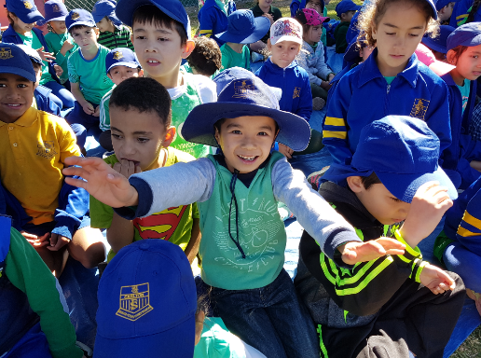
Our school has a tradition of excellence and opportunity, balancing academic strength with physical and creative programs to inspire every student.
We provide a safe and secure learning environment. Our well-managed classrooms and co-operative playground demonstrate our effective student care and discipline programs. Our student leadership and peer support strategies develop confident and caring individuals.

Carlton PS has a strong academic focus, with programs to extend every student. Resources and programs that offer advantage are well established. Our large staff of talented and dedicated teachers delivers a breadth of knowledge and depth of experience many schools envy.

The school is situated in the Sydney suburb of Bexley and has an enrolment of 835 students in 2019. Students are organised into a structure of 33 classes from Kindergarten to Year 6 and come from diverse socio-economic and cultural backgrounds. 93% of students come from language backgrounds other than English and 1% identify as Indigenous Australians. The school has an extensive community languages program providing classes for students in Chinese, Arabic, Macedonian, Greek and Maori languages. Indonesian is offered as a language other than English to all other children. Additional support programs are provided in the areas of Learning Assistance and English as a Second Language. The school has a full time and part time teacher librarian.
The school is well supported by an active Parents and Citizens Association who contribute funding to the school on an annual basis, provide feedback on school programs and work to promote the strong sense of community at Carlton Public School. In addition, parents are actively involved in many classrooms and activities such as excursions.
The school provides a range of performing arts and sporting programs giving students the opportunity to participate in extracurricular activities and represent the school at higher levels. Promoting student voice is a priority and students are given opportunities to develop leadership skills through the Student Representative Council, Peer Mediation Program and in elected leadership positions. A strong emphasis is placed on the use of technology to enhance learning.

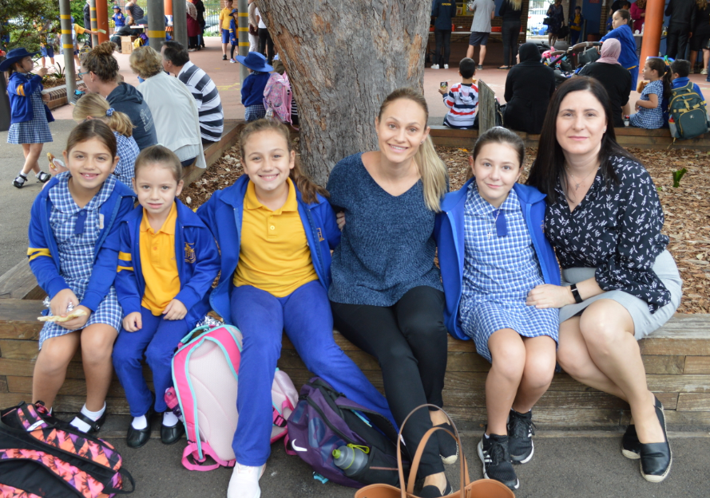

School Vision Statement:
Our vision is to educate students to become creative and critical thinkers, motivated and engaged learners. They will become proud, resilient, responsible and active local and global citizens.

We will achieve this through the provision of challenging, innovative learning programs delivered by high performing staff in an inclusive, safe and supportive learning community.

Carlton Public School is a PBL school. PBL stands for Positive Behaviour for Learning.

Positive Behaviour for Learning is an evidence-based whole school systems approach that:
- addresses the diverse academic and social needs of every student to support them to be successful
- supports students in early childhood settings through to senior years of schooling
- enables schools to establish a continuum of supports that are intensified to meet the needs of every student
- is team driven, using a problem solving approach (data, systems and practices) that engages students, parents and all school staff
- establishes positive social expectations for all in the school community
- provides a framework for the school and its community to collectively support the wellbeing of every students.
Our school rules and values are based on the following three expectations and are applied to a variety of school settings:

- Be Safe

- Be Respectful

- Be an Engaged Learner

A
BORIGINAL EDUCATION
The Aboriginal Education Policy is committed to promoting the education and achievements of Aboriginal students and also includes guidelines to educate all students about Aboriginal Australia. The importance of improving employment, education, participation and lifelong learning opportunities for Aboriginal people and communities underpins the Department of Education and Communities Aboriginal Education Policy.

ATTENDANCE & ABSENCES
Regular attendance at school makes learning easier for your child and helps build and maintain friendships with other children.

Education and Public Instruction Act 1987
School attendance is compulsory for students aged 6 to 17.
The law requires your child to attend school on each day that instruction is provided unless prevented by sickness or other good reason.
An explanation (written note) is required if your child is absent.

If your child is absent from school, a note giving the reason must be provided to the child's class teacher as soon as the child returns to school. If the absence is going to be longer than three days, it is expected that on the third day the parent inform the school of the reason for the child's continued absence. Please try to make children's appointments with dentists, doctors etc. before or after school hours.

School hours: Students from Kindergarten to Year 6 attend school from 9.00am to 3.00pm. The school grounds are supervised between 8.30am and 3.00pm. Parents are requested not to send students to school before 8.30am. Students are expected to be picked up by 3.00pm. Kindergarten students finish school at 2.30pm from February to mid-March.

Late arrivals: Parents are required to accompany children to the Administration office if they are late for school to obtain a late note to give to the teacher. If children are continually late, the Principal will request an interview with the parent and the Home-School Liaison Officer may be consulted.

Early leave: If your child is to leave the school before the finish of the day's lessons, a note to the teacher is required. Please go to the office to obtain an early leave pass before collecting your child.

Extended Holiday leave: If your child is going to be absent from school for any period in excess of 15 school days, an exemption from school attendance needs to be applied for three weeks prior to the intended leave. A form is available from the school office.

ACCIDENTS
All teachers are trained in Emergency Care procedures. In the case of an accident in the classroom or playground your child will be treated with simple first aid administered by the teacher on duty. If necessary your child will be taken to the office and further first aid will be given by the First Aid Officers. You or your contact person will be notified immediately if further medical attention is necessary. Please ensure the school has an up-to-date phone number for emergency calls. The school will call an ambulance if a child has been seriously injured. We only treat minor injuries in our sick bay.

AIR CONDITIONING
At Carlton Public School all classrooms are air-conditioned. Also, the library and administration block are air conditioned.

AMBULANCE COVER
The school contributes to the NSW Ambulance Fund and should it be necessary for a child to be transported to hospital by ambulance, there will be no charge to the parent. If you receive an account for payment for transportation due to an injury at school, please bring the account to the office and we will verify it with the school account number and stamp.

ANAPHYLAXIS
Anaphylaxis means that a child may have a severe allergic reaction should they come in contact with some foods. This can be a life threatening condition. We ask your cooperation in not sending any of the following foods for your children, whilst they are at school: Peanuts and or peanut butter, other nuts (including cashews, hazelnuts, walnuts, pistachios, macadamia, brazil nuts & Nutella) and muesli bars containing nuts. We also ask that you pass this request to others who may prepare food for school such as grandparents or child minders.

ANNUAL SCHOOL REPORT
The Annual School Report provides parents and members of the wider community with information about Carlton Public School’s achievements, programs, evaluations and targets. The report is available on the school’s website.

ANTI-RACISM POLICY
The Department of Education is committed to the elimination of racial discrimination – including direct and indirect racism, racial vilification and harassment – in its organisation, structures and culture, in its curriculum, and in the learning and working environment for which it is responsible. If you believe that you or your child has been the victim of some form of racism at school, please talk to the Principal. The school has a designated Anti-Racism Contact Officer.

ASSEMBLY
A whole school assembly is held on weekly on Mondays to present awards and celebrate significant achievements. Parents are invited to attend this assembly as well as the Kindergarten – Year 2 Assembly held weekly on Mondays.

B

EFORE AND AFTER SCHOOL CARE
Before and After School Care is offered at the school in the school hall and lower Block A. The centre is presently run by Helping Hands. The centre operates from 7.00am to 9.00am and from 3.00pm to 6.00pm each school day. Also, Helping Hands run a vacation care program most school holidays. Brochures are available in the office foyer.

BIRTHDAYS
Students like to celebrate their birthday or name day at school. If parents wish to celebrate a birthday please assist by sending small cupcakes so that they can be handed out easily to the students in the class. Please do not send a large cake. Some classes may have special needs due to allergies. Please check with your child’s class teacher before bringing cakes to school. All cakes must be nut free.

BOOK CLUB
A pamphlet published by Scholastic Book Club is sent home once or twice each term. Ordering procedures are listed on the brochure. All orders are completed on-line and payment procedures are also completed on-line. No orders can be left at the school office. Volunteer parents will distribute orders to the students when they arrive.

BOOK WEEK
Book Week is held in Term 3 when a focus is placed on the School Library, books and literature. There are many activities held during Book Week e.g. visiting performances, competitions and lunchtime activities which are organised by the Librarian and are related to children’s literature.

BUSES
Buses provide transport for students to and from Carlton, Hurstville and Rockdale train stations. Please check at the office for the bus company particulars and assembly points. Bus pass applications are available from the school office. Students in Kindergarten to Year 2 are eligible for a free bus pass. Students in Years 3-6 are eligible if they live 1.6km or more from school. An eligibility map is held at the school.

C

ANTEEN
The school canteen is a privately leased canteen accredited with the Canteen Association as a healthy canteen. It is operated by licensed manger and is open each day before school, at recess, during lunch time and after school. The food available is chosen for its nutritional value and appeal. Foods high in salt, fat and sugar are not sold at the canteen. The Canteen Price List is displayed in the canteen, on the school website and given to parents on a regular basis. Lunch orders need to be written on a paper bag with your child’s name, class and order clearly on the front with the money included. No credit will be given. Please hand orders to the canteen before 9.00am.

CASUAL TEACHERS
When a class teacher is on leave, participating in professional learning or working on a school based project, a casual teacher is employed by the school to teach the children. Occasionally a casual teacher cannot be found and it is necessary to split classes and separate students into other classes. Class teachers prepare work for the children to continue with when they will be absent.

CHANGE OF ADDRESS AND PHONE NUMBER
It is essential that you notify the school office immediately when you change address or home, work or mobile telephone numbers. The school must also have the phone numbers of friends or relatives who can be contacted in an emergency if you cannot be reached.

CHARITIES
Stewart House is the main charity supported by the school. Stewart House consists of a government school and a statutory health corporation operating together on the one site at South Curl Curl. Stewart House School provides a unique service for 90 students each fortnight referred by the public school system from across NSW and the ACT. A used clothing collection and other fund-raising activities are held to support Stewart House. We also support World Vision in sponsoring a child in Indonesia. Money is collected through fund raising activities. The Student Representative Council also support chosen charities during the year.

CHESS LESSONS
Chess lessons are available to students from Kindergarten to Year 6 and are held once a week before school. The lessons are operated by a private tutor and payment is required each term. Informal chess competitions are also conducted by a staff member.

CHILD PROTECTION
The school conducts a Child Protection Program each year for all students K to 6. The aim of child protection education in primary schools is to assist students to develop skills in recognising and responding to unsafe situations, seeking assistance effectively and establishing and maintaining relationships and strengthening attitudes and values related to equality, respect and responsibility. The Department of Education requires all school staff to inform the principal when they have reasonable grounds to suspect risk of harm to a child or young person. Teachers are expected to be aware of the indicators of abuse and neglect and to assist by providing relevant and available information to the principal who may make a report to the Child Well Being Unit or to the Department of Community Services (DOCS).

CLASS RESOURCE FEE
The resource fee is paid to cover the purchase price of class resources used by the students which may include items such as a diary, text books, home reading bag, library bag, Accelerated Reader subscription, School Magazine subscription and Mathletics.

COMMUNITY LANGUAGES
Five community languages are taught at Carlton Public School: Arabic, Greek (not all year groups), Maori (not all year groups), Macedonian and Mandarin. Only students from these cultural backgrounds are able to learn the language. Students from other backgrounds learn Indonesian as a language other than English.

COMPETITIONS
Each year the students in Years 2 – 6 have the opportunity to enter external competitions in English & Mathematics. All students who enter receive detailed results of their performance. All students have the opportunity to take part in the Premier’s Reading Challenge and the Premier’s Spelling Bee.

COMPLAINTS/CONCERNS

No matter how effective the communication between home and school, there are times when parents may become concerned about something that is happening at school. These concerns may be about things happening in the classroom, in the playground or sometimes even at home. If a parent or student has a complaint we would like to know about it, rather than it go unresolved. Concerns are best addressed straight away, rather than waiting until the problem gets worse. Parents are encouraged to approach the class teacher first. Appointments can be made through the administration office.

In some cases, especially for problems involving other children, or problems involving staff members, parents are encouraged to approach the Stage Supervisor, Deputy Principals or the Principal. Specific problems arising from school practices should also come to the Principal. Parents are always welcome to phone or call to arrange an appointment. The vast majority of concerns will be satisfactorily resolved at school. However, when this is not the case, there are formal procedures set out for resolving complaints. Parents wishing to make a formal complaint will need to speak with the Principal.

COMPUTERS
All classes have significant access to technology resources. Most rooms have an Interactive Whiteboard and at least one or more computers. There are several computers in the library, a computer lab in A Block for whole class use and a Mini Lab on the top floor of Block A for Year K - 2 students. There are also several banks of laptop computers and iPads that can be moved around. All classrooms and the library have access to the Internet.

COUNSELLOR
The Department of Education provides each school with the services of a trained school counsellor who is based at our school two days per week. Teachers who have a concern about a student will refer the student to the school's Learning Support Team. The school counsellor liaises with parents to assess the needs, strengths and special problems of the child and then determines appropriate programs. The counsellor can give teachers and parents access to resources and personnel within and beyond the school setting. Parental approval is sought when psychometric testing is considered necessary. The school counsellor is also involved in presenting aspects of the Student Welfare and Personal Development programs.

CURRICULUM
The seven key learning areas are English, Mathematics, Science & Technology, Personal Development, Health and Physical Education, Creative Arts and Geography and History. For each of these curriculum areas there are syllabus documents and guidelines from the NSW Department of Education and the NSW Education Standards Authority (NESA). Copies of these documents are kept in the school library and are available on the NESA website.

CUSTODY AND OTHER LEGAL ISSUES
If there is any custody or other legal issues that may affect the welfare of your child, please discuss the matters with your child's class teacher and the Principal. In addition, please ensure that the school has a copy of any relevant Court Orders.

D

ISCIPLINE & SCHOOL RULES

Students are expected to display an acceptable standard of behaviour in the classroom, playground, travelling to and from school, during excursions and other school activities held away from the school site. The code of conduct, which lists five basic student rights and their related responsibilities, has been developed to help create a positive and supportive environment in which emphasis is placed on the development of self-discipline in each student. The school’s merit & discipline systems are guided by the Positive Behaviour Learning Program. Details of the school's strategies to encourage positive behaviour and address misbehaviour are published in the school's Student Welfare Policy, which you will be given when you enrol your child. It is also available on the school website at https://carlton-p.schools.nsw.gov.au/

E
MAIL
Parents can contact the school by email at carlton-p.school@det.nsw.edu.au.
Provision of your current email address will allow the school to share information with you about current school events. All students have a Department of Education & Communities email account which they can access through the student portal at https://student.det.nsw.edu.au once they have been allocated a user name and password.

ENGLISH AS AN ADDITIONAL LANGUAGE OR DIALECT (EAL/D)
English as an Additional Language or Dialect (EAL/D) Education aims to develop students' English language competence and improve their learning outcomes throughout the curriculum to a level where they can fully participate in schooling, independently pursue further education and training and effectively contribute to Australian society. Specialist teachers, along with classroom teachers assist students who need additional support to learn English.

ENROLMENT
Students who are 6 years or older can enrol any time during the school year. If transferring from another school, an enrolment form will be printed by the office with details from the previous school. Kindergarten children who attain the age of 5 years by 31st July may enrol in that year. Children who turn 5 after 31st July and eligible children not enrolled by the end of Term 2 must wait and enrol in the following year. The school has an obligation to verify the date of birth of all enrolling students, so please ensure that the school sights your child’s original birth certificate (if born in Australia) or their passport (if born overseas) when enrolling. A copy of your child's Immunisation History Statement is also required. Be sure to note on the enrolment form any allergies, conditions or medications. The school must also sight proof of your residential address e.g. an electricity bill, gas bill or lease agreement.

EXCURSIONS
Excursions are arranged by class teachers throughout the year and are a valuable enhancement to the curriculum. Departmental policy states that excursions must be part of the educational process and therefore must be linked to classroom activities. The cost of excursions is kept to a minimum. Payment is always made in advance and parents informed in writing of relevant details. A signed permission note is required to verify child attendance for an excursion. Costs for excursions are calculated according to the number of students expected to attend. Requests for non-attendance at an excursion are usually not refundable. Students are to wear school shoes, full school uniform, a school hat and bring their recess and lunch in a named plastic bag, unless otherwise stated.

Payment for excursions & performances: Excursions and performances arranged by the school are non-profit making activities. Therefore, students cannot attend these functions if they are not paid for. If parents are having difficulty paying for an activity, they may request assistance from the Deputy Principal in writing. Each request will be considered on its merit and dealt with confidentially. Students involved in out-of-school sporting fixtures are required to pay transport and other costs such as singlet hire.

G

REEK Language Learning – after school

In addition to the Community Languages program that is offered during regular school time, students from a Greek background have the opportunity to attend Greek language classes which are organised by the Greek Church at Kogarah. Lessons are held each Friday after school.

H

ATS
School hats are to be worn every day during play, at sport and on excursions. The school Sun Safe Policy is No hat, play in the shade. Students are encouraged to stay in the shade on very hot days. Please ensure your child’s full name is written clearly inside their hat.

HEAD LICE
Anyone can get head lice and it is very common for school children to get head lice at some time. Head lice can spread when children’s hair comes into contact with one another. To prevent your child getting head lice: tie your child’s hair back, tell your child not to share hats, clothes or brushes, check your child’s hair regularly. If your child has head lice: continue to send your child to school as long as treatment has commenced, inform the school so we can inform others to check their children’s hair, your child will not be identified. Parents are asked to check their child’s hair using the methods and treatments recommended on the Health Department website:
http://www.health.nsw.gov.au/publichealth/environment/headlice/index.asp

HOME SCHOOL LIAISON OFFICER

The Home School Liaison Program provides a supportive service to students, parents and schools to encourage the attendance of students at school. The Home School Liaison Officer calls at the school each term, to check absences recorded by teachers and identify any consistent patterns of lateness or unexplained absences by students.

HOMEWORK
Students learn well if their parents are interested in their learning and try to help them at home. Parents can help their children by talking about school activities and supervising homework tasks. Homework should be appropriate to the child’s age and relevant to the knowledge and developing skills of the child.

GUIDELINES FOR HOMEWORK

Kindergarten
- Library borrowing
- Sound Work &/or Home Reading - 10 minutes for four nights a week

Years 1 & 2
- Library borrowing
- Home reading - 10 to 15 minutes for four nights a week
- Language/Spelling activities at least once a week - may not be a written task
- Maths activity once a week

Years 3 & 4 – 30 minutes each day (maximum)
- Library borrowing
- Home reading - 15 to 20 minutes for four nights a week
- Homework tasks - 10 to 20 minutes for four nights a week - may be in any subject area but emphasis will be on English & Mathematics

Years 5 & 6 – 40 minutes each day (maximum)
- Library borrowing
- Home reading - 15 to 20 minutes for four nights a week
- Homework tasks - 20 to 25 minutes for four nights a week - may be in any subject areas but emphasis will be on English & Mathematics

After school activities such as music, dance, swimming and sports are important educational activities and students should be encouraged to participate in areas of interest. Everyday family tasks such as shopping, cooking or planning for weekends can all be educational experiences. At any time if parents do not want students to complete some or all of the homework please write a note to the class teacher.

I

MMUNISATION
Students entering school are required to have an Immunisation History Statement from the Australian Childhood Immunisation Register (ACIR) stating a complete or incomplete record of immunisation. These certificates are sent to parents once a child has received the vaccination due at four years of age or can be downloaded from the internet. Please visit www.medicareaustralia.gov.au/online. Students who are not immunised may be excluded from the school during an outbreak of a vaccine preventable disease.

INTERNET ACCESS AND EMAIL
The NSW Department of Education provides children with an internet and email account to help improve their learning opportunities in a safe environment. Children are provided with an individual username and password to log in to the internet at school. This means their access to the internet or World Wide Web will be filtered to help stop inappropriate sites from being seen. Your child also has an email account which lets them send and receive written messages. Students access their email account from the Student Portal at https://student.det.nsw.edu.au. Permission for children to access the internet is obtained from parents when they enrol their child at school.

L

EARNING SUPPORT TEAM
The Learning Support Team is a whole-school planning and support mechanism. It is formed with the purpose of addressing the learning needs of students through the coordination, development, implementation, monitoring and evaluation of educational programs. The team assists teachers to plan class programs to meet the specific learning needs of all students, including those who experience difficulties in learning. Requests for support can be made by teachers and/or parents and are made by referral to the Learning Support Team.

LIBRARY
The library contains a wide collection of books and is staffed by two teacher librarians. One librarian is employed five days per week and the other two days per week. We encourage students to borrow books and ask parents to ensure that books are cared for and returned on time. A library bag helps to protect books when they are being taken to and from school. Kindergarten students are given a library bag when they commence school. The library borrowing system is a computerised bar code system that records which books have been borrowed. The Internet is also available in the library for use with classes.

LOST PROPERTY
Lost property can be found in the tub outside the school office. If not there, please check with your child’s class teacher, the Library or the hall. Please label everything that your child brings to school with your child’s full name e.g. child’s bag, lunch box and school clothes so they can be returned if lost. Please check regularly that the name is able to be read clearly and has not faded. Items with names on them will be returned to the students.

LUNCH
Lunch is from 1.10pm to 2.00pm Monday – Thursday. The first ten minutes is spent eating lunch in the classroom. On Friday lunch is early from 11am – 11.50am. Students can bring lunch from home or it can be ordered from the canteen. It is important that lunch be nutritious and appealing. It is not possible for food to be heated at school. Some classes may have students with special dietary needs and life threatening allergies so please be aware of the school anaphylaxis policy. Please label all lunch boxes and plastic drink bottles clearly with your child’s name.

M

EDICATION
Only medication prescribed by a doctor can be administered at school by one of the Administration staff authorised by the Department of Education to administer some medications. If a child is on a prescribed medication the parent must come to the school office and discuss the matter with the Principal or Deputy Principal. A Health Care Plan must be completed by a doctor before any medicines can be given. Parents and carers are to deliver all medications to the school office. Please make sure the medicine box/bottle contains the chemist’s label with details of the medication, dosage and time to be administered as advised by the doctor. Medicines without these details cannot be administered.

MESSAGES
Occasionally parents may need to ring the school to give an important message to their child. All attempts will be made to find your child and convey the message to him or her. Please ring before 2.30pm. Students are not to come to the phone unless it is an exceptional situation.

MEET THE TEACHER MEETINGS
These are informative meetings for parents that are held early in the school year. As well as meeting your child’s teacher and other parents, you will hear about classroom organisation, homework, rules, expectations, excursions and ways that you can help your child and be involved with their learning. This is not the time for an individual interview about your child’s progress.

MOBILE PHONES
Mobile phones are not allowed to be carried by students at school unless permission has been sought from the Principal. Mobile phones are very expensive items and if lost or stolen will cause your child distress. Students who bring mobile phones to school do so at their own risk and the school will not accept any responsibility for any loss or damage. There is a school policy on the use of mobile phones and other electronic devices. Please ask for a copy of the policy at the school office.

MONEY COLLECTION
Payment for school activities can be made in cash or using the Online Payment Process. Payments are to be made using an envelope marked with your child’s name and class that includes the excursion/sport event together with the excursion note or a note with the reason for the payment. The envelope is to be placed in the money collection box in the Administration Office. Payments for excursions, class resources, school contributions etc over $10 will be invoiced and a receipt will be issued to the family. Other excursions $10 or less will not be receipted to the family, but will be recorded and bulk receipted to the class.

MULTICULTURAL EDUCATION

Multicultural education is for all students and school communities. It promotes cultural understanding and community harmony. Multicultural education aims to equip all students with the knowledge, skills and values needed to participate successfully in Australia's culturally diverse society. Focus areas for multicultural education include:
- English as an Additional Language or Dialect
- Refugee support programs
- Interpreting and translations
- Cultural diversity and community relations
- Anti-racism education.

N
ATIONAL ASSESSMENT PROGRAM (NAPLAN)
Students in Years 3, 5, 7 and 9 sit for the National Assessment Program Literacy and Numeracy (NAPLAN) tests in May. The assessments are an opportunity for students to demonstrate what they have learnt in class, and their achievements are measured against national performance standards. Teachers use the results to meet the individual literacy and numeracy needs of all students. There are four tests covering numeracy, reading, writing and language conventions (spelling, punctuation and grammar). Students who have been learning English for less than a year need not take the tests. Results from these tests are available later in the year. Parents are encouraged to discuss the results with the class teacher. The MySchool website provides information for parents about the NAPLAN tests. It can be accessed at http://www.myschool.edu.au.

NEWSLETTER
The newsletter is published each Thursday on the school website at http://www.carlton-p.schools.nsw.edu.au. Parents can subscribe to have the newsletter emailed directly each Thursday by visiting our website and following the link in the Newsletters tab. Also, the school app includes the newsletter. To reduce our significant printing costs, paper copies have ceased to be printed.

P

ARENTS & CITIZENS’ ASSOCIATION
Our school has an active Parents & Citizens Association. The P&C meet twice a term on a Tuesday night in Weeks 3 & 7 of the school term commencing 7pm. The meetings provide a forum where parents can participate in making decisions and raise matters of interest or concern. Fund raising activities organised by the P&C include Mother’s Day & Father’s Day events, competitions and other school celebrations. They also hold a 2nd hand uniform sale each term.

PARENT PARTICIPATION
We encourage parents to participate in their child’s education through:
- Asking about your child’s progress and attending Parent / Teacher interviews
- Sharing information or concerns with the class teacher or executive staff
- Attending P&C meetings
- Attending social functions & school events
- Helping around the school with reading, maths, writing, art/craft, covering books
- Discussing daily learning and homework with your child
- Attending the Sports and Swimming Carnivals and other special events
- Volunteering to work on school committees
- Responding to surveys sent home by the school

PARENT TEACHER INTERVIEWS
The school encourages good communication between parents and teachers. Three Way Interviews including students are conducted at the end of Terms 1& 3. Written reports are issued at the end of each semester. Parents are welcome to contact their child’s teacher to arrange an interview at any time during the year. Please note that teachers are not available to speak to parents during class time or at the line up areas in the playground.

PARKING

Parents are asked to obey all road rules and parking signs in the streets surrounding the school. There are large fines for illegal parking around schools. The school will not support any appeals against fines issued by the police or parking officers.

POP (Parent on Line Payment)
‘Parent on Line Payment’ is an online payment option available for parents to pay any
school expenses via the privacy of your own home instead of sending cash to the office
with their child. This option is available through our School Website. It is still necessary
for the permission note attached to the payment request to be placed in the collection box
at the office.

R

OAD SAFETY
Road Safety is taught as part of the Physical Development, Health, and Physical Education syllabus. We encourage all parents to discuss Road Safety with their
children. Each year we participate in Walk Safely to School Day when parents are
encouraged to reinforce road safety with their children as they walk to school together.

S

CHOOL A-Z

Parents can support their child's learning with a new resource that includes a website, mobile applications and social media channels. The School A to Z online school community, developed by the Department of Education, provides practical advice about homework tips on learning, wellbeing, technology and resources to help parents and carers support their child's social, physical and mental development. It includes a free mobile application for iPad and smartphones that features hundreds of definitions about maths and English terms, illustrated examples and instructional videos, information on common assignment topics, educational maths and spelling games. School A to Z also includes: forums on Facebook and Twitter to allow parents to share experiences, tips and hints online; printable homework help sheets; A-Z lists of English, maths and technology definitions and `assignment starters on popular classroom topics.

The site offers information on technology and resources on how to keep kids safe online, along with nutritious lunch box recipes and a section on health and wellbeing.

Visit the website at http://www.schoolatoz.nsw.edu.au

SCHOOL ADMINISTRATIVE & SUPPORT STAFF
The School Administrative & Support Officers in our school’s office area undertake reception and secretarial duties, student enrolment, banking, first aid and a hundred and one other tasks. They assist teachers with the care of students, the preparation of lesson materials and the maintenance and storage of equipment. The School Administration Manager supervises the office staff and is responsible for the administration and accounting procedures within the school. To contact the school please phone 9587 3717, fax 9553 8307 or email carlton-p.school@det.nsw.edu.au

SCHOOL BOUNDARIES
Students can enrol at Carlton Public School once the address of the enrolling family has been entered and checked online within the guidelines of the Department of Education school enrolment program.

SCHOOL CAPTAINS/PREFECTS
At the end of each year the Year 5 students have the opportunity to nominate for the positions of captain or vice-captain for the next school year. The captains hold the position for the full school year. Prefects are elected on a rotating basis each term from the Year 6 students. Captains and prefects are selected on their ability to set a good example for the other students by their positive behaviour and attitude. They help teachers, guide visitors, assist with assembly, and have office and canteen duty and other duties when needed.

SCHOOL HOURS
Children are to attend school Monday to Friday between 9.00am & 3.00pm during school terms. Kindergarten students finish at 2.30pm for the month of February until early-March. Supervision of students in the playground is available from 8:30am. Students are not supervised after 3.00pm and it is school policy that all students leave the grounds by 3.10pm unless attending the Before & After School Care facilities.

SCRIPTURE
Parents of students in Years 1 - 6 can elect for their child to receive religious instruction for 30 minutes on Wednesday mornings from representatives of the following faiths:
- Anglican/Protestant
- Catholic
- Church Of The Living God
- Greek Orthodox
- Islam
ETHICS
Students in Years 1-4 are offered the opportunity to attend Ethics classes during scripture time. Primary Ethics’ classes support children to develop their moral reasoning capabilities. The focus is on skills development rather than the promotion of any particular view.

Students who do not attend scripture classes are supervised by a teacher during this time, formal lessons are not taught. If parents do not wish their child to attend scripture please indicate this on the enrolment form or by sending a letter to the Principal.

SICKNESS AT SCHOOL
Occasionally students become sick at school. They are placed in the sick bay and monitored. If it becomes obvious that they need the care of a parent, a call is made to home or work. In the case of a simple injury unless urgent attention needs to be sought they are given basic first-aid and either sent home or back to class. The school will arrange for an ambulance if the child is in need of urgent medical assistance. Please do not send your child to school if he/she is unwell.

SKOOLBAG APP

The Skoolbag app can be downloaded onto your smartphone. Currently, the app is used for alerts, newsletter articles, notes & calendar.

SMOKE FREE POLICY
It is the policy of the Department of Education that smoking is not permitted inside the school grounds and buildings or at school events held at outside venues. All staff, parents and visitors are to comply with this policy.

SPORT
K – 2: Individual teachers take their own class for fitness, games and gross motor activities as part of the Health Physical Education & Personal Development syllabus requirements. Sport is arranged for Kindergarten and Stage 1 at a set time each week and advised to parents at the start of each year.
Years 3 – 6: Students are able to select from a range of sports activities held at school each Friday morning. Students participating in school sports, learn specific skills and games e.g. cricket, ball games, softball etc. Students may also participate in elective sports activities which may include tennis, gymnastics or other types of leisure activities when arranged. Costs are involved for these elective activities.

Primary Schools Sport Association (PSSA)
Children in Years 3 – 6 may be selected to participate in a range of competitive sports. PSSA involves students going away from the school and playing against other schools.

SPORTS CARNIVALS
The school Swimming Carnival is held in Term 1 for students in Years 3 – 6 and some children in Year 2 who turn 8 years of age. The Cross Country Carnival for students in Years 3 – 6 is held in Term 2. The Athletics Carnivals are held during Term 3. The Kindergarten to Year 2 children participate in races and novelty events. Students in Years 3 – 6 participate in competitive events and have the opportunity to represent the school at Zone Carnivals.

STUDENT REPORTS
Parents will receive two written reports each year. The reports will give you a clear picture of your child’s achievements. They will help you understand how your child is progressing and how we can support your child’s future learning. The reports are indicative of the achievement level of students across each Key Learning Area. The report also includes written comments and indicates progress in social skills, attendance and attitudes to learning.

STUDENT REPRESENTATIVE COUNCIL (SRC)
The Student Representative Council is made up of elected class representatives from Years 2 - 6 and meets regularly to develop leadership skills, consider matters of interest to the students and make recommendations to the Principal.

SWIMMING
An Intensive Swimming Scheme is offered in Term 4 for students in Years 2 to 6 with Year 2 students having the priority. There is a charge for pool entry and bus fare but no charge for the swimming instruction.

T

EACHER MEETINGS
The teachers meet fortnightly on Thursday morning at 8.30am for an administration meeting and Tuesday afternoons after school at 3.00pm for stage meeting and professional learning activities. Teachers are not available to meet with parents during these times.

TERM DATES
School term and holiday dates for future years are available on the Department of Education and Communities website: http://www.schools.nsw.edu.au/calendar/?do=setViewPeriod&categoryid=21&viewType=yearView

TRANSFERRING TO ANOTHER SCHOOL
Parents are asked to let the office staff know if their child is leaving our school at least one week before the date and we expect that all accounts are paid to date and that library books and all other school equipment is returned before you leave.

U

NIFORMS
Carlton Public School is a ‘uniform wearing’ school. Parents are asked to ensure that their child comes to school each day in full uniform. School uniforms are available for sale from Lowes at Rockdale Plaza. Please label all clothes with your child’s name. Black school shoes are required and students can wear sport uniforms and joggers on sports days.

V

ALUABLES
Apart from a wrist watch, valuables should not be brought to school. This includes items of jewellery, mobile phones, electronic games, toys and expensive items that students may break or lose at school. Students who bring valuables to school do so at their own risk and the school will not accept responsibility for any loss or damage.

VOLUNTARY CONTRIBUTIONS
Schools can request contributions to enhance the school's educational and sporting programs. These school contributions are voluntary and payment is a matter for decision by parents. They help provide additional educational resources for the benefit of students. Schools may also charge students for the purchase of materials used in particular subjects. At Carlton Public School each family is asked to help the school by paying the school voluntary contribution when requested.

W
EBSITE
The school has an excellent website that provides information on the school in general, the Annual School Report and School Plan, newsletters and information notes, term calendar, curriculum information, school policies and more. The address for the web site is https://carlton-p.schools.nsw.gov.au/

We Develop the whole child using the Learning Disposition Wheel!
